ContactManagement_Verify Contact notes _Instance44_12-Jul-2018_03-05-15_AM_SingleSignOn.png

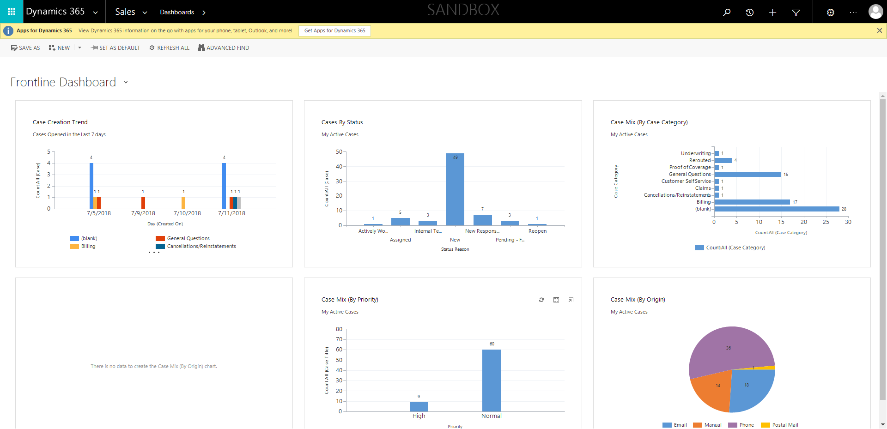

ContactManagement_Verify Contact notes _Instance44_12-Jul-2018_03-05-29_AM_Validatingcontactentitynavigation.png

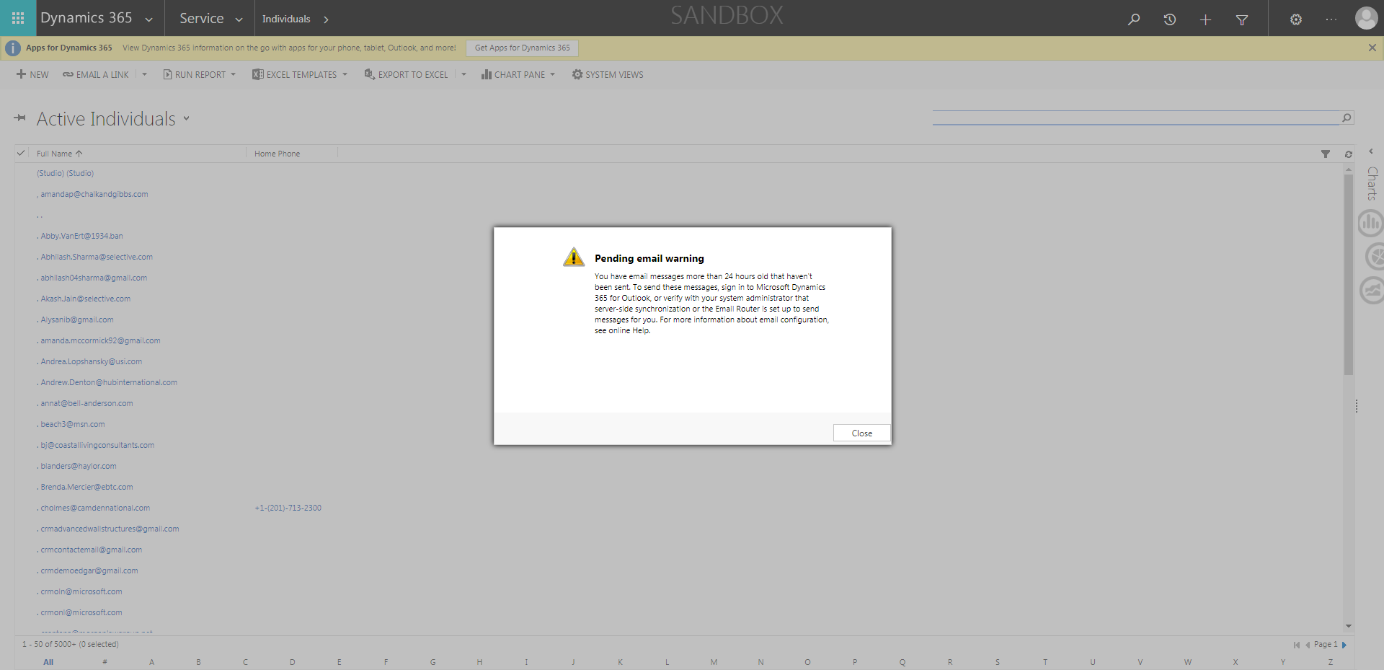

ContactManagement_Verify Contact notes _Instance44_12-Jul-2018_03-04-58_AM_MouseClickActiononStaleElement.png



ContactManagement_Verify Contact notes _Instance44_12-Jul-2018_03-05-11_AM_SingleSignOn.png

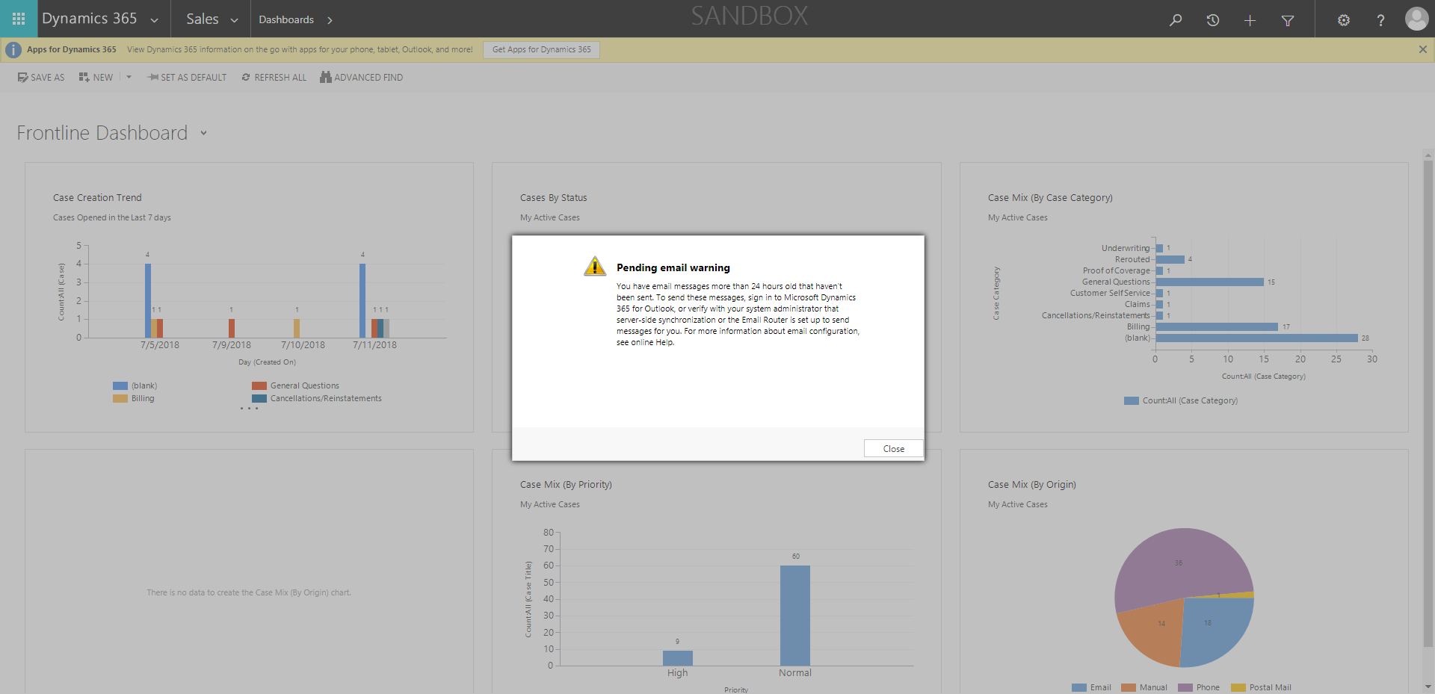

ContactManagement_Verify Contact notes _Instance44_12-Jul-2018_03-04-56_AM_MouseClickActiononStaleElement.png



ContactManagement_Verify Contact notes _Instance44_12-Jul-2018_03-05-40_AM_VerifyingAllNotesofanindividual.png

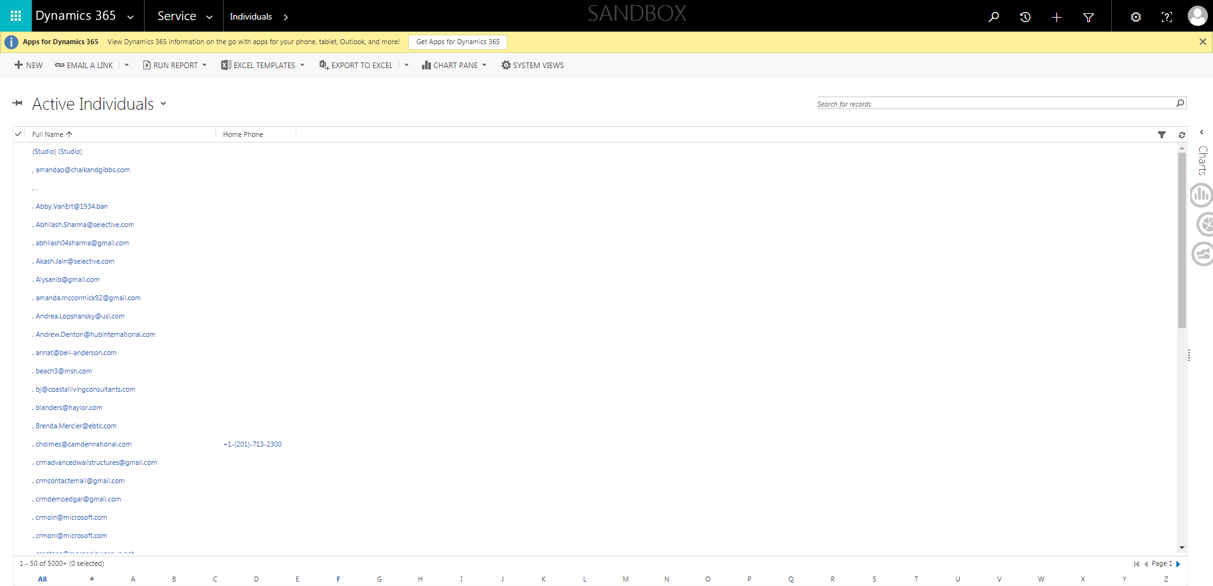

ContactManagement_Verify Contact notes _Instance44_12-Jul-2018_03-04-57_AM_EnterTextAction.png

